I had uninstalled all packages with “python” on an Ubuntu Server 18.04. BIG MISTAKE because it broke the NIC, the NIC could not get an IP address. I played around with the NIC but got nowhere

So I figured out how to reinstall python3 packages (without Internet) by downloading from ubuntu web side then saving them on Ext USB HD, then running sudo dpkg -i packagename.deb for each package

NOTE: running “sudo dhclient eth0” may have been the way to get an IP address at least through DHCP.

Long story short, after that then

Sudo install netplan

Sudo install netplan.io

I had also had to create a text file named /etc/default/netplan. It is just a text file and had to the following line “ENABLED-1”.

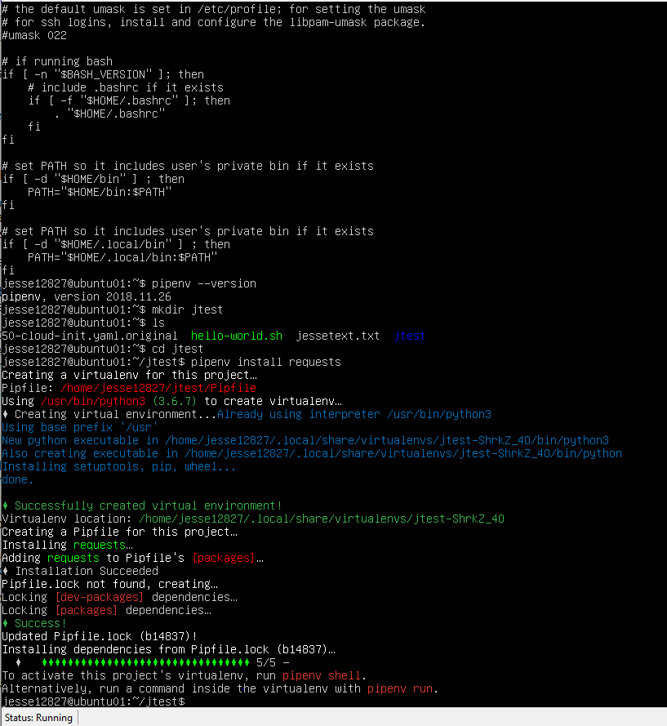

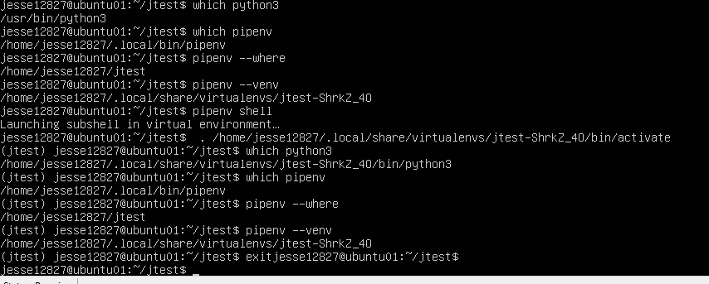

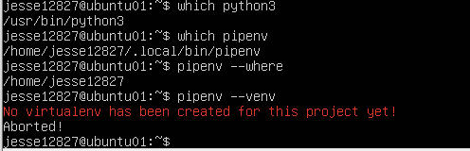

HAD TO REINSTALL NETPLAN and NETPLAN.IO

Sudo apt install netplan

Then got screen below but still no IP Address using /etc/netplan/50-cloud-init.yaml

So did

Sudo apt install netplan.io

That seemed to work using the IP Address configured in /etc/netplan/50-cloud-init.yaml

